Which Stock has better returns?

Google, Amazon and Apple are 3 Tech-Giants who play major role in the Stock Market. Visualizing the Net traded value, percentage change in average stock value and percentage change in volume of stocks traded over 5 years depicts interesting findings on which stock will give us a high return. Is it Apple, Google or Amazon?

# Rationale for the visualization

To answer the posed question visualize the percentage change in average stock value and percentage change in volume of stocks traded for the three companies. It shows that Apple and google follows a similar trend and is almost stagnant in terms of percentage change in average stock value and showing a decreasing trend (in negatives)in percentage change in volume of stocks traded. Whereas Amazon on the other hand has a steep increase in stock value over the years and is volatile in terms of volume of stocks being traded. So it is advisable to invest in Amazon compared to Google or Apple.

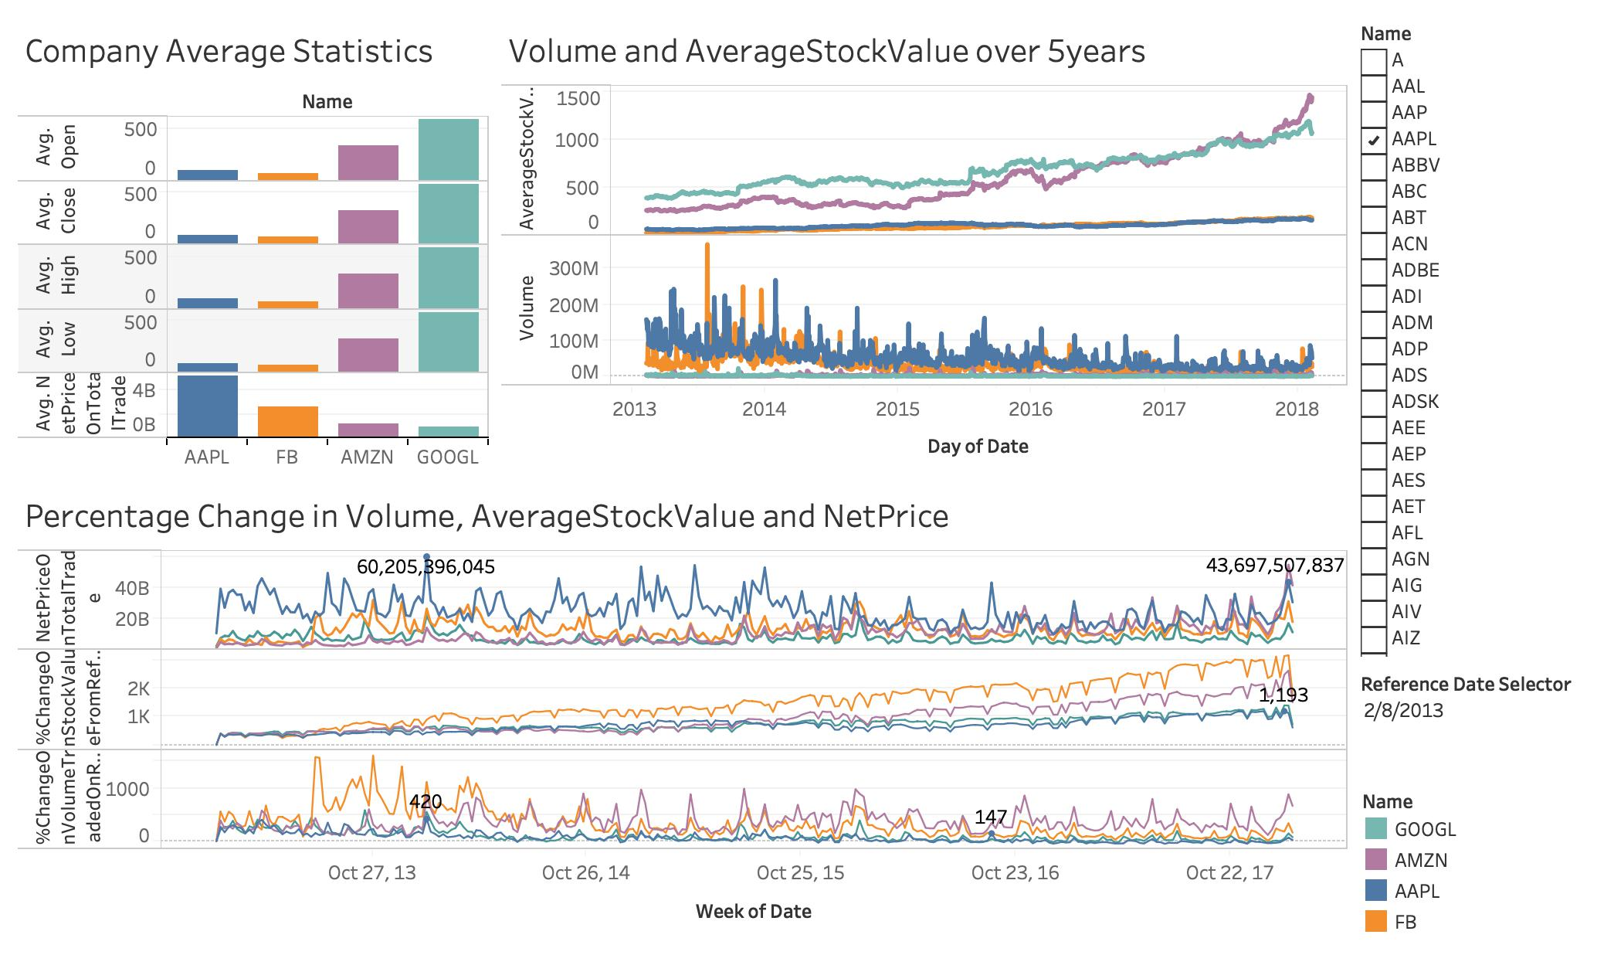

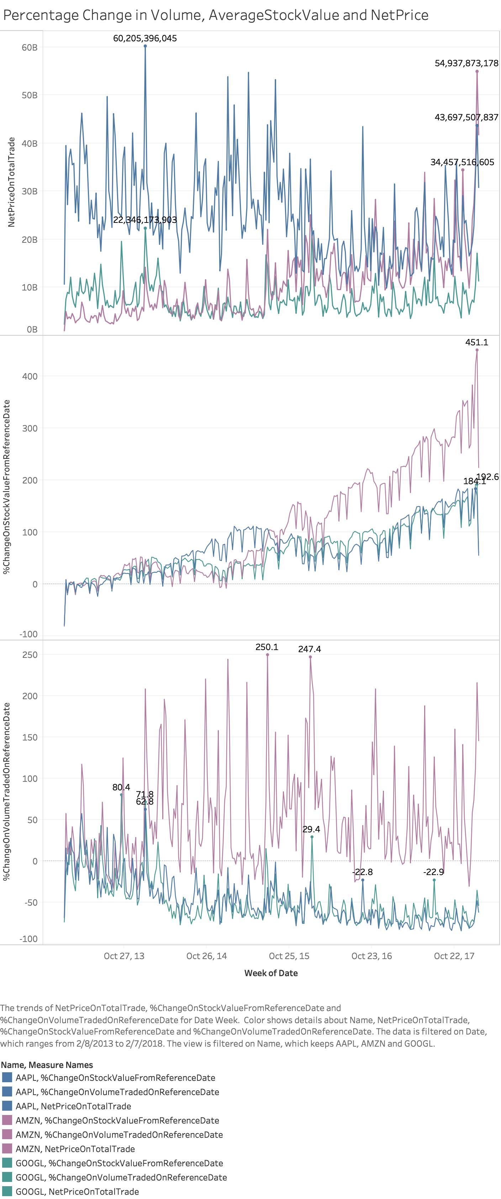

# Design

The data is on historic stock prices and to show the maximum **amount** of **continuous** data in **minimum space** I used a time line graph. This choice was made due to the fact that I was aiming to show the trend and volatility of stocks for 5 years.

I choose to depict my data in 3 different charts instead of using same graph to show all 9 trends, as that will overcrowd the graph and makes it less efficient, more complicated and harder to decipher. Another issue with using same graph is the issues with scaling.

Date was set to be continuous variable to facilitate the eyes to follow a definite path **instead of discrete points which can create distortion**. It **shows almost the entire data** on the 3 companies selected, as the calculated fields use high, low and volume.

Also, **to facilitate comparison** between companies I used **different colors** depicting each company and for comparison between 3 variables(Volume, average stock price and net value) I used 3 graphs on same x axis. Different pieces of data are compared like this.

The lines showed trends but to add **details and to further the level of understanding,** I labeled the peaks in the graphs.

The three companies represent **3 categories of data and hence different colors** are used and background color is consistent and **not distracting.** This helps to invite viewers attention directly to the data. Use of soft and natural colors like blue and green for Google and apple, and light purple for Amazon draws our attention to Amazon which is a more suitable option for investment as per data and calls for more attention.

The values depicted are percentages but as the reference date changes the percentage can go negative or positive and since there was an exponential growth for Amazon **the scale** was customized to 500 to -100 for Stock value and 250 to -100 for volume. But the scale for net stock price is shown in billions ranging from 0 to 60 billion. To avoid any confusion due to this change in design, labels are used. These scales are large enough to contain all the data points and small enough **to avoid extra data ink**. Also, the visualization is directly proportional to the data and the **lie factor is taken care of**.

**Size** of the lines were made thinner so as not to make the visualization too invading and distract the audience from the fact that the lines represent just connected data points.

All these techniques help in communicating the data effectively, minimizing distortion and facilitating easy cognition. Human eyes are trained to iteratively accumulate information and the linear way in which line graphs represent data helps in cognitive amplification.

The 3 similar graphs helps in easy comparison between different variables and different companies. The colors are selected to draw attention to the most important data (Amazon in purple). Scales used are percentages of the real data to ensure graphical integrity which also allows viewer to see the bigger picture.

# Tools Used

Different features in Tableau were used to visualize the data. **A temporal line graph** was the main tool. The x-axis represent week of continuous dates(columns) and 3 sets of y-axis(rows) represent net price on total trade, % change in volume and % change in stock value. These are calculated fields and the equation is given in Appendix A. Marks are used to represent different names. Different colors are used for this purpose. Two parameters were also created to select reference date(Slider) and the company(Checkbox). Labels, captions and legends are used to make the visualization more informative and defeat distortion and ambiguity.

# Appendix A

## Calculated Fields

**%Change of Average Stock value Calculation with reference to a given date**

* AverageStockValue = (High+low)/2
* AverageStockValueOnReferenceDate = WINDOW_MAX (IF MAX([Date]= [Reference Date Selector]) then SUM([AverageStockValue]) ELSE NULL END, FIRST(),LAST() )
* %ChangeOnStockValueFromReferenceDate = 100*((SUM([AverageStockValue])-[AverageStockValueOnReferenceDate])/[AverageStockValueOnReferenceDate])

**%Change of Volume of Stocks traded Calculation with reference to a given date**

* VolumeOnReferenceDate = WINDOW_MAX (IF MAX([Date]= [Reference Date Selector]) then SUM([Volume]) ELSE NULL END, FIRST(),LAST() )
* %ChangeOnVolumeFromReferenceDate = 100*((SUM([Volume])-[VolumeOnReferenceDate]) /[VolumeOnReferenceDate])

**NetPrice=Volume*AverageStockValue**